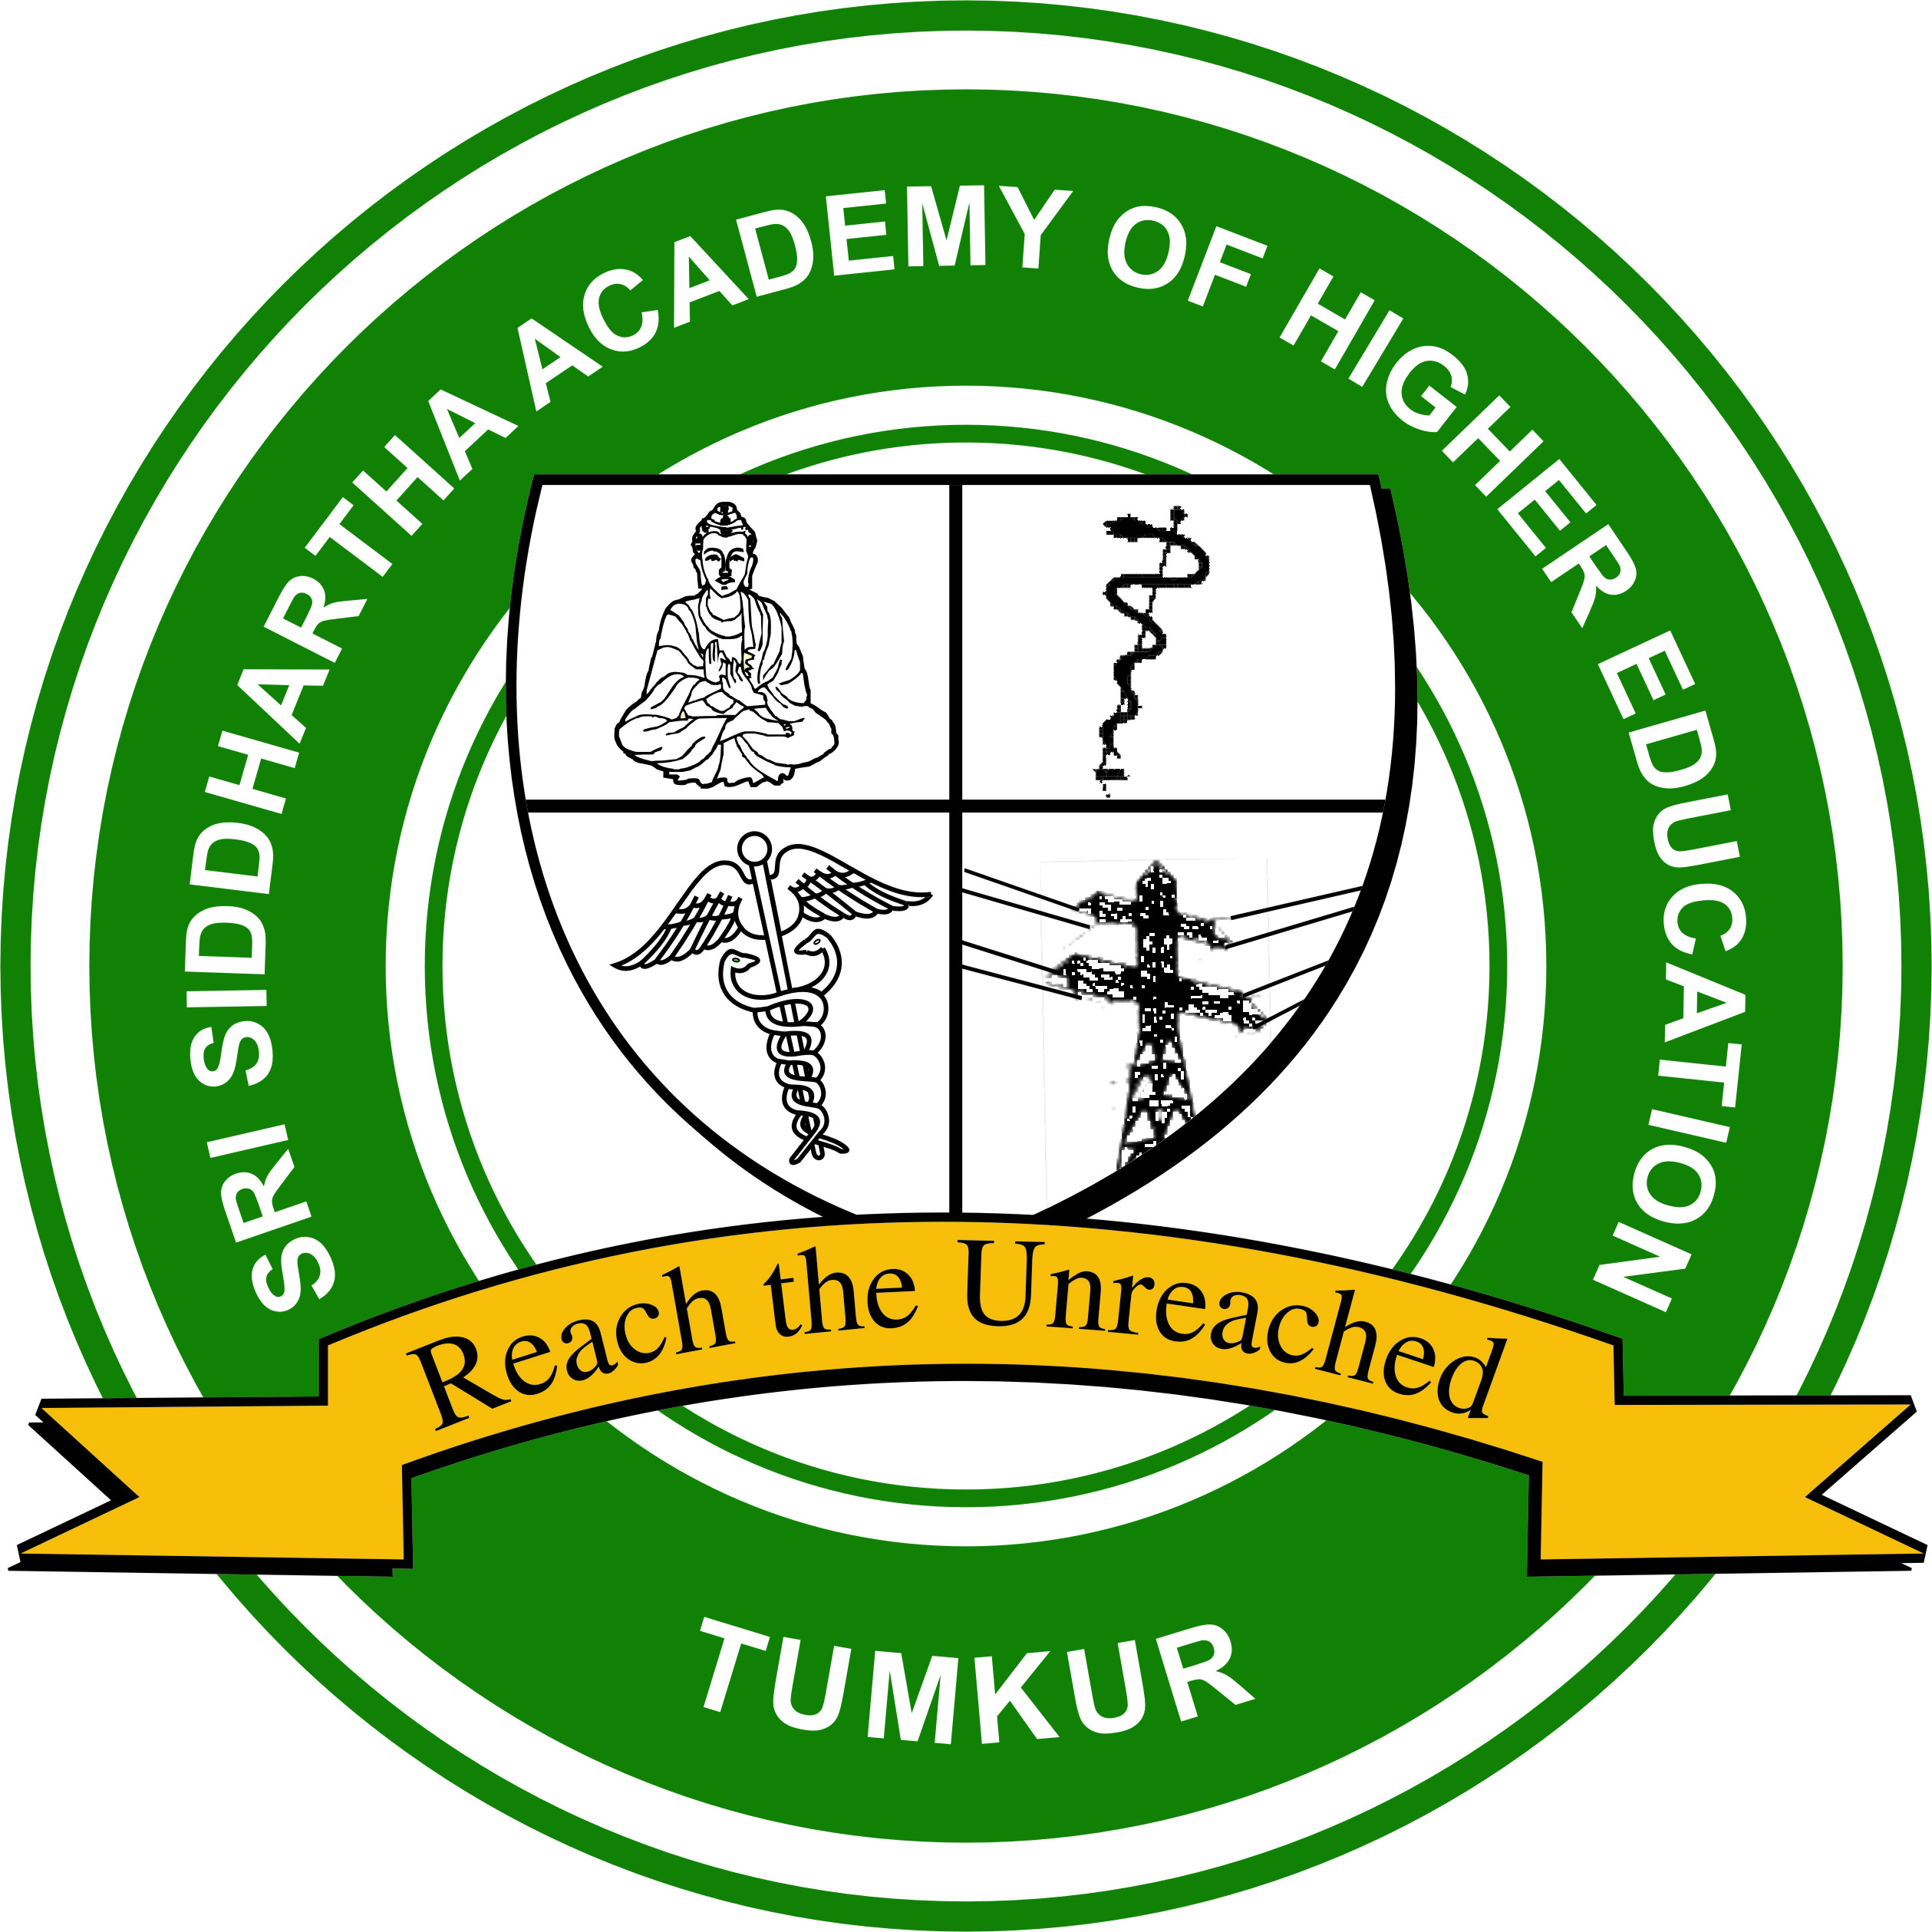
SRI SIDDHARTHA ACADEMY OF HIGHER EDUCATION
(DEEMED TO BE UNIVERSITY)
Declared under Section 3 of the UGC Act, 1956, MHRD GOI No. F.9-31/2006-U.3 (A) dated: 30/05/2008
Accredited ‘A’ Grade by NAAC
Agalakote, B.H.Road, Tumkur – 572 107.KARNATAKA, INDIA.
Ph. 0816- 2275516, 2275512 , Fax : 0816-2275510 website: sahetumkur.ac.in email: info@sahe.in , iqac@sahe.in

4.4.4: Facilities for e-content development such as Media centre, audio visual centre, Lecture Capturing System (LCS), etc.
Sri Siddhartha Medical & Dental Colleges
- Use of Student Management System to access class schedule, student test scores, grades etc.
- The institute subscribes to a large number of full-text electronic journals which are available to all staff and students.
- Online lecture capture system is provided to students with campus-wide access to lecture materials from their device of choice.
Sri Siddhartha Institute of Technology
- The Institute campus has Media centre, which houses a community radio, Television studio, video-editing laboratory, and Language lab.
- ‘Radio Siddhartha’ is the first community radio station in Tumakuru. The main objective of Radio Siddhartha is to assist the neighborhood community comprising of students, teachers, public and mainly the farmers.
- Language laboratory enables language learning by human interaction with mechanical assistance. It is CALL-based (Computer Assisted Language Learning), functioning as a multimedia lab for all the stakeholders.
- The Institute is one among the few institutes in South India to offer a full-fledged Apple iMac based multimedia lab. It helps the students and faculty to familiarize themselves with Mac OS and provides them exposure to the state-of-the-art editing software ‘Final Cut Pro’ (FCP).
- The Institute has a modern television studio which enables the students and faculty to develop useful teaching and learning resources.

